Glowing Effect:

The glowing effect is created by overlaying different “shadows” of the text. So what we do is create different shadows of the text (decrasing intensity and increasing size). We use the CSS attibute text-shadow:
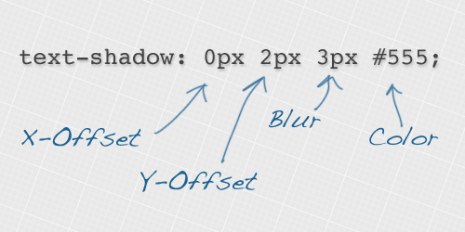

What this property will do is creating a copy of the text:
- Displaced using the X-Offset and Y-Offset (Required Parameters)
- Applied a blurring filter of “Blur” pixels (Optional)
- The shadow has the color “Color”

Usually you create more than one layer to create better glowy effects. Example:

h1 {
text-shadow: 0 0 3px #FF0000, 0 0 5px #0000FF;
}

Background:

Our background is goint to be this image:

z index is how far the layer is (matters for overlaying)

Images sizes and Responsiveness:

We want out page to be well seen no mather the screen resolution and size (not the same, your phone can have a lot of resolution (number of pixels) but is very small.

Our solution (I dont fucking care what others do):

We will set all parameters (CSS) using absolute values in pixels (never % ). And using as reference for desing, the normal screen values of a computer: (1360 x 768 ) (16:9). This way we can have visual consistency.

If we want to reescale this parameters to other screen size, we just reescale these values with javascript. For that we need to obtain the actual screen size.

Screen Size:
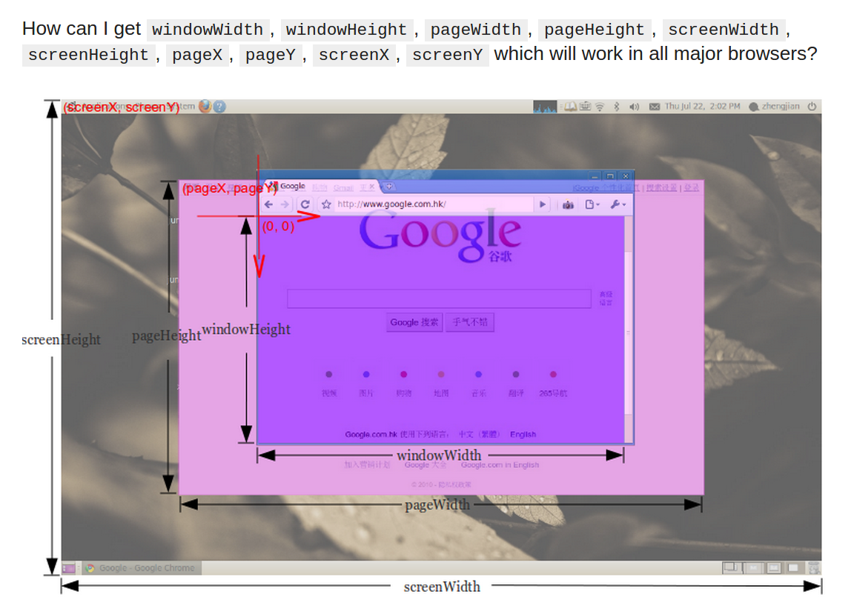
Also take into account that if your browser is using magnificarion 150% or so, the values of page and window will be reduced accoring to it.

CSS property clear is very important along with float. Using clear:both, a div does not alow other floating divs to be around and it will be putted after the floating, objects, not with them.

In our page, the problem is that our “container” div that has a blackish background does not go till the end because a floating object is not part of the div, so the div does not increase.

